Chapter 11: Services and System Administration

11.1 From Process to Service
In UNIX and Linux environments, software execution is organized hierarchically around processes. To understand systems administration, an engineer must distinguish among a generic process, a daemon, an operating system service, and a managed systemd unit.

Core Distinctions
- Process: Any executing instance of an executable program managed by the kernel. A process possesses a unique Process Identifier (PID), an address space, execution state, and descriptors tied to open files and execution contexts. Most interactive processes attach directly to a controlling terminal (tty or pseudo-terminal pts).
- Daemon: A specialized background process designed to execute autonomously without direct interactive terminal intervention. Historically, daemons detached themselves from controlling terminals via double-forking (fork()), closed standard input/output streams, and attached their execution lifecycle to the initial root process (PID 1).
- Service: A continuous or persistent capability offered by the operating system or an application runtime. Services often run in the background (as daemons) to handle ongoing tasks—such as processing incoming network requests, serving local domain socket queries, or polling hardware sensors. While many services provide network capabilities via listening sockets, others execute ongoing computation, batch execution, or asynchronous maintenance entirely without listening sockets (e.g., cron schedulers, kernel log dispatchers, system stats reporters).
- systemd Unit: A standardized encapsulation entity managed by the systemd system and service manager. Units represent distinct operating system resources described in declarative configuration files (.service, .socket, .target, etc.). Wrapping a program inside a systemd unit enables uniform dependency enforcement, execution monitoring, standardized lifecycle management, sandboxing, resource containment (via Linux control groups / cgroups), and centralized logging.

Fundamental Unit State Matrix
systemd evaluates every managed unit across multiple distinct state axes. Conflating these dimensions is a common diagnostic error:

State Vector | Target of Evaluation | Primary State Values | Architectural Significance
Loaded | Configuration parse state | loaded, not-found, bad-setting, error | Reflects whether systemd located, read, and validated the unit configuration file from storage into active memory.
Active | Runtime execution status | active (running), active (exited), inactive (dead) | Reflects whether the program or process encapsulated by the unit is currently operating in host memory.
Enabled | Boot/Activation configuration | enabled, disabled, static, masked | Reflects whether filesystem symlinks exist to automatically trigger unit execution during target transitions.
Failed | Operational exit classification | failed (with exit code or signal details) | An abnormal runtime state entered when a service crashes, encounters an unhandled signal, exceeds start timeouts, or exits non-zero.

11.2 System Architecture and the 5-Stage Boot Sequence
Understanding how Linux transitions from hardware initialization to user services requires examining the five-stage boot architecture.
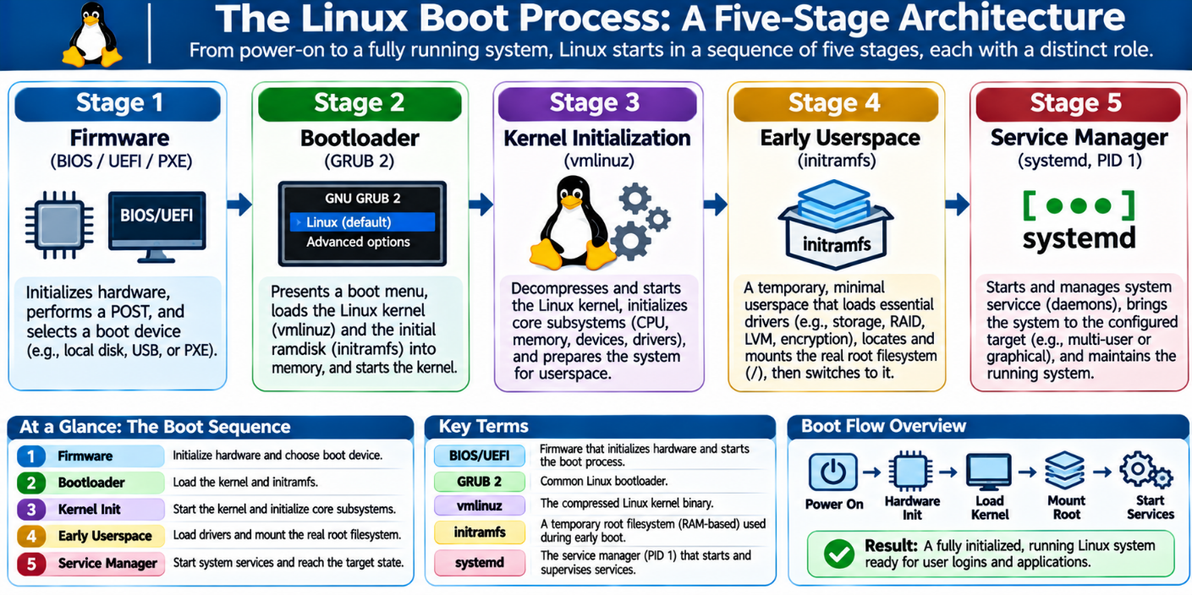
Figure 11.1: The 5-Stage System Boot Sequence from Silicon Initialization to Multi-User Target.

Stage 1: Platform Firmware (BIOS / UEFI / PXE)
Upon electrical power application, the system central processing unit executes firmware instructions located in non-volatile motherboard flash storage.

- Legacy BIOS: Executes a Basic Input/Output System sequence, performs the Power-On Self-Test (POST), checks hardware integrity, and reads the first 512 bytes (Master Boot Record or MBR) of the designated boot disk.
- Modern UEFI: Executes the Unified Extensible Firmware Interface, reads partition tables using the GUID Partition Table (GPT) scheme, inspects the dedicated EFI System Partition (ESP), verifies digital signatures (if Secure Boot is enabled), and executes native EFI applications.
- PXE Boot: Alternatively initializes the network interface controller, obtains IP addressing via DHCP, and retrieves the initial bootloader over the network via TFTP or HTTP.

Stage 2: Bootloader Execution (GRUB 2)
The firmware transfers control to the bootloader, typically the Grand Unified Bootloader (GRUB 2). The bootloader fulfills three critical operations:
- Provides an interactive menu or timed default selection for available kernel configurations.
- Reads filesystem drivers to locate the selected compressed kernel image (/boot/vmlinuz-<version>) and the corresponding early userspace memory archive (/boot/initramfs-<version>.img).
- Loads both the kernel binary and the initramfs image directly into system RAM, passes command-line parameters (kernel arguments such as root=UUID=... ro quiet splash), and transfers execution control to the uncompressed kernel entry point.

Stage 3: Kernel Initialization
The Linux kernel unpacks its components and asserts complete control over hardware:
- Initializes memory management, CPU caches, paging mechanisms, and core scheduler threads.
- Initializes low-level virtual filesystem abstractions (/proc, /sys).
- Detects core platform hardware buses and initializes statically compiled built-in drivers.
- Prepares to transition control from kernel execution space to userspace.

Stage 4: Early Userspace (initramfs)
Because modern operating systems use complex storage topologies (such as RAID, LVM volumes, LUKS full-disk encryption, or network filesystems like NFS/iSCSI), the kernel cannot immediately mount the real root filesystem (/) using built-in drivers alone:
- The kernel unpacks initramfs (Initial RAM File System), a small temporary root filesystem residing purely in RAM, and executes its /init script.
- This early userspace environment loads essential modular device drivers (e.g., NVMe controllers, AHCI modules, cryptsetup engines).
- It locates, unlocks, and mounts the real persistent root filesystem (/) in read-only mode.
- It uses the pivot_root or switch_root system call to discard the temporary initramfs memory footprint and pivot the system's real storage mount to root (/).

Stage 5: System and Service Manager (systemd as PID 1)
With the actual root filesystem mounted, the kernel executes the initial userspace program—/sbin/init, which is symlinked to systemd on modern Linux distributions:
- systemd assumes Process ID 1 (PID 1) and acts as the parent or ancestor of all userspace processes.
- It parses unit files from filesystem storage (/lib/systemd/system, /etc/systemd/system).
- It resolves dependency trees, activates target synchronization points, sets up socket and D-Bus interfaces, and launches default runtime targets (such as graphical.target or multi-user.target) in parallel.

Diagnostic Boundary: Kernel Panic vs. Service Failure
Systems engineers must distinguish between a Kernel Panic and a Userspace Service Failure:
- Kernel Panic: Occurs during Stages 3 or 4 when the kernel encounters an unrecoverable low-level condition—such as corrupted internal memory tables, missing hardware drivers required to read root storage, or the total inability to find and execute PID 1. The entire operating system halts immediately. No userspace logs or shells are accessible.
- Service Failure: Occurs during Stage 5 within userspace. If a service (such as an Apache web server, an SSH daemon, or a database) fails to start or crashes, PID 1 isolates the failure, logs the crash vectors to the system journal, and continues executing all other operational units. The operating system kernel remains healthy and fully interactive.

11.3 Hardware Discovery and Driver Subsystems
Proper systems administration requires inspecting hardware components and kernel subsystems without destabilizing the running environment.
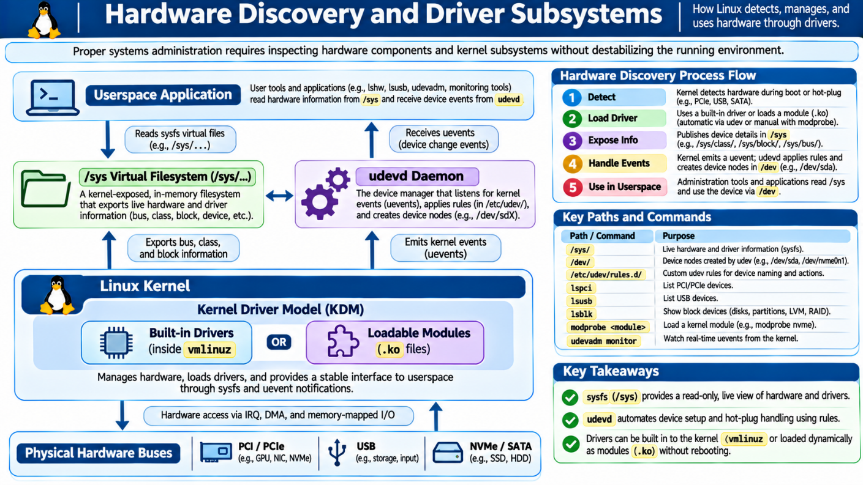
Figure 11.2: Interaction of Physical Hardware, Drivers, sysfs, and Userspace Device Management.

Observational Commands vs. Destructive Interventions
Production systems administration emphasizes non-destructive observation over blind reconfiguration. Modifying driver modules or kernel parameters on operational servers can sever network communication, destabilize storage arrays, or induce kernel panics.

Commands restricted from safe student observation labs include:
- modprobe / rmmod / insmod: Dynamically insert or yank binary modules out of running kernel space.
- udevadm trigger: Forces userspace re-processing of all kernel hardware rules, which can reset network interfaces or alter device links.
- Arbitrary writes to /sys or /proc: Overwrite running kernel configuration parameters.

Hardware Discovery Toolset
The following read-only commands allow safe, detailed observation:

1. PCI/PCIe Hardware: lspci
The Peripheral Component Interconnect (PCI) and PCI Express (PCIe) buses host high-throughput components such as network controllers, storage controllers, and graphics processing units.
- Syntax: lspci -nnk
- -nn: Displays both textual device descriptions and numeric vendor/device IDs (e.g., [8086:15d8]). These IDs are critical for matching hardware against raw driver compatibility databases.
- -k: Shows the kernel driver currently controlling the device (Kernel driver in use:) and available driver modules (Kernel modules:).

2. USB Topologies: lsusb
The Universal Serial Bus (USB) subsystem handles removable and peripheral hardware.
- Syntax: lsusb -t
- -t: Dumps the physical USB device layout as a hierarchical tree, showing root hubs, external hubs, operating transfer speeds (e.g., 480M for USB 2.0, 5000M/10000M for USB 3.x), and bound driver subsystems.

3. Block Storage Devices: lsblk
- Syntax: lsblk or lsblk -f
- Visualizes physical storage disks, solid-state drives, NVMe namespaces, partitions, LVM volume groups, and current filesystem mount points without altering partition tables.

4. Kernel Module Inspection: lsmod and modinfo
Device drivers in Linux exist in two forms:

- Statically Compiled Built-in Drivers: Built directly into the vmlinuz binary image; always resident in memory and cannot be unloaded.
- Loadable Kernel Modules (LKMs): Independent compiled object files (.ko or .ko.zst) stored on disk (typically under /lib/modules/$(uname -r)/) and loaded into kernel memory on demand when hardware is discovered.
- lsmod: Reads /proc/modules to show all currently loaded kernel modules, their memory footprint, and which other modules depend on them.
- modinfo <module_name>: Extracts metadata from the module file on disk—including author, license, firmware requirements, aliases, and configurable parameter switches—without loading or executing the module.

Low-Level Virtual Filesystems and Device Subsystems
- /sys Virtual Filesystem (sysfs): An in-memory virtual filesystem generated by the kernel, mounted at /sys. It exports the kernel's internal device-driver model to userspace:
  - /sys/bus/: Organized by physical bus architecture (e.g., pci, usb, scsi).
  - /sys/class/: Organized by functional device class (e.g., net, block, power_supply).
  - /sys/block/: Symlinks pointing to all block-level storage devices.
- The udev Userspace Device Manager: When hardware is connected, the kernel detects the bus transition and emits a uevent message. The userspace daemon systemd-udevd catches this event, parses declarative rules in /etc/udev/rules.d/ and /lib/udev/rules.d/, dynamically creates or cleans device nodes in /dev/, applies correct ownership/permissions, and generates persistent symlinks (such as /dev/disk/by-uuid/).
- Interrupt Requests (IRQ) and Direct Memory Access (DMA):
  - IRQ: A hardware signaling line allowing a peripheral device to interrupt the CPU to request immediate processing of pending tasks (e.g., incoming network packet arrival).
  - DMA: A capability that allows high-speed hardware devices to transfer data directly to and from system RAM without routing the raw data continuously through the CPU, reducing host processing overhead.

11.4 systemd Units and the systemctl Command
The primary tool for interacting with systemd is systemctl. Understanding its commands and unit typing is central to Linux operations.

Common systemd Unit Types
systemd classifies operational resources into unit types designated by file extensions:

Unit Extension | Functional Role | Operational Behavior
.service | Process / Daemon execution | Encapsulates process startup, execution style, environment variables, restart policies, and shutdown sequences.
.socket | Socket-based activation | Encapsulates IPC, network, or FIFO sockets. Listens on behalf of a service; when traffic arrives, starts the paired .service unit.
.target | Synchronization point | Groups units together to establish system states or runlevels (e.g., multi-user.target, sockets.target).
.timer | Chronological scheduling | Provides timer capabilities similar to cron jobs, with monotonic and calendar scheduling bound to a matching .service.
.mount | Filesystem control | Controls filesystem mount points in userspace, automatically generated from /etc/fstab or created manually.

Diagnostic Unit Inspection Commands
To inspect system units without root privileges, append the --user flag. This connects systemctl to the per-user systemd instance:

Display comprehensive status of a unit (lifecycle, state, PID, memory, recent logs)
systemctl --user status <unit_name>

List all service units currently active and running in memory
systemctl --user list-units --type=service --state=running

Query exclusively whether a unit is currently executing (returns 0 if active)
systemctl --user is-active <unit_name>

Query exclusively whether a unit is configured to start at boot/login
systemctl --user is-enabled <unit_name>

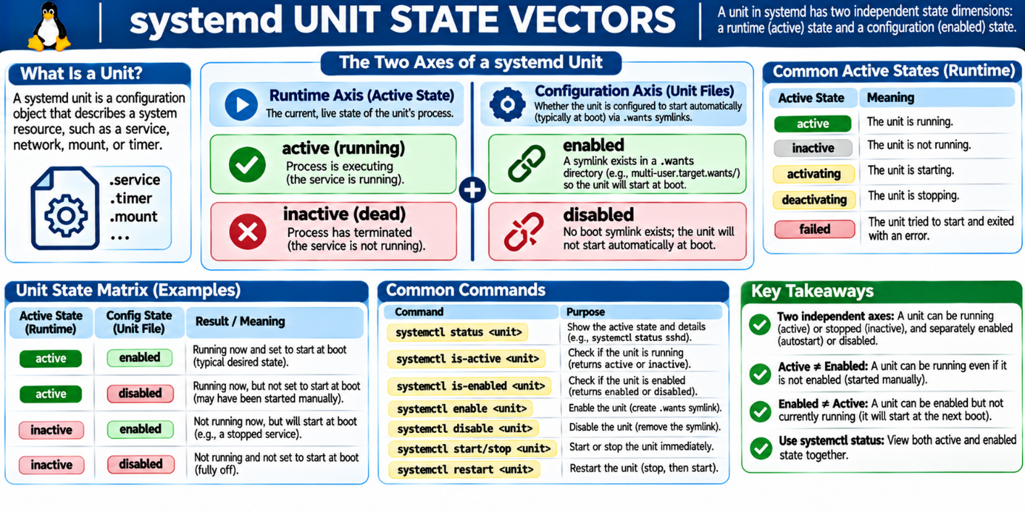
Figure 11.3: Visualizing the Independence of Active Execution and Enabled Configuration.

The Active vs. Enabled Separation
A core principle of systemd design is the decoupling of runtime state from persistent configuration:

- Active State: A volatile, real-time measurement of whether the service's process is currently executing in host memory.
- Enabled State: A persistent, filesystem-level configuration that determines whether the service will be automatically invoked during system startup or user session initialization.

Because these two mechanisms operate independently, a service can be active but disabled:

- If an administrator executes systemctl start example.service, systemd launches the process into memory immediately (active).
- If the administrator never executed systemctl enable example.service, no activation symlinks were created on disk (disabled).
- When the server reboots, systemd does not launch the service. It remains inactive until manually started again.

11.5 Unit Lifecycle Operations
Manipulating unit lifecycles requires precision. Commands that appear functionally similar often perform entirely different tasks behind the scenes.

[Stopped / Inactive]
|
| systemctl start
v
[Active (Running)] <----+
| |
| systemctl | systemctl restart
| reload | (Terminates PID, creates new PID)
| (SIGHUP; |
| retains PID) |
v |
[Re-reads Config] ------+
|
| systemctl stop
v
[Stopped / Inactive]
Figure 11.4: State Transitions for Unit Lifecycle Commands.

Comparing Lifecycle Operations
- start: Instructs systemd to read the unit configuration, resolve prerequisite dependencies, execute the binary defined in ExecStart=, and transition the unit state to active.
- stop: Sends a termination signal (typically SIGTERM) to the running processes defined within the unit's control group. If the process does not terminate within the configured grace period (TimeoutStopSec=, default 90s), systemd sends SIGKILL to force-stop it, setting the state to inactive.
- restart: A destructive sequential operation. It stops the running service, terminates its execution context and active connections, and then launches a completely new instance with a new Process ID (PID).
- reload: A non-destructive operation. It does not terminate the process and preserves running connections. It sends a signal (typically SIGHUP) or invokes a dedicated configuration reload command (ExecReload=), instructing the software to re-read its configuration files from disk while continuing to serve active clients.
- daemon-reload: Does not start, stop, or reload any service processes. Instead, it instructs the systemd manager itself (PID 1 or user manager) to scan the filesystem, re-read and parse all unit files in unit search paths, and rebuild internal dependency trees. This command is required whenever a unit file is created, modified, or deleted on disk.

The Mechanism of enable and disable
The enable and disable commands manage filesystem symlinks; they do not launch or terminate software:
- Executing systemctl enable <unit_name> reads the [Install] block within the unit file. It creates a symbolic link in the designated target's .wants or .requires directory (e.g., ~/.config/systemd/user/default.target.wants/<unit_name>).
- Executing systemctl disable <unit_name> deletes that symbolic link from the target directory.
- Important Behavior: Running systemctl enable <unit> does not start the service immediately. The service will only launch during the next boot or target activation unless explicitly run with the --now flag:

systemctl --user enable --now <unit_name>

11.6 Anatomy of a Service Unit File
A systemd service unit is a plain-text declarative configuration file split into standardized sections: [Unit], [Service], and [Install].
[Unit]
Description=Demonstration Sleep Service for Linux System Administration
Documentation=man:systemd.service(5)
After=network.target

[Service]
Type=simple
ExecStart=/usr/bin/sleep infinity
Restart=on-failure
RestartSec=5s

[Install]
WantedBy=default.target

Deconstructing Unit File Sections

1. The [Unit] Section
Defines metadata and establishes dependency and ordering relationships:
- Description=: A human-readable label identifying the service in logs and monitoring dashboards.
- Documentation=: URIs pointing to man pages or documentation files.

2. The `[Service]` Section
Defines execution behavior and runtime parameters:
- Type=: Specifies how the service notifies the manager that it has finished initializing.
- simple (default): systemd assumes the service starts immediately upon executing the binary in ExecStart. The binary must not fork.
- forkin`: The service calls fork() to spawn a background daemon. systemd tracks the parent process until it exits, then monitors the remaining child PID.
- oneshot: The process executes, performs a finite task, and exits cleanly before systemd proceeds with dependent units.
- ExecStart=: The exact binary command line to execute when the unit is activated.
- Restart=: Defines restart policies if the process exits unexpectedly (e.g., `no`, `on-failure`, `always`).
- RestartSec=: Delay to wait before attempting a restart.

Critical Execution Detail: Binary Pathing and Shell Context
Unlike commands entered into an interactive bash prompt, ExecStart= does not invoke a shell by default:
- The primary binary must be declared as an absolute, fully qualified path (e.g., `/usr/bin/sleep`, not simply `sleep`).
- Standard shell features—such as wildcard expansion (`*`), input/output redirection (`>`, `<`), pipes (`|`), and variable substitution—do not work within `ExecStart=` unless explicitly wrapped inside a shell invocation:
# Example of wrapping complex commands in an explicit shell
ExecStart=/bin/sh -c "exec /usr/local/bin/app >> /var/log/app.log 2>&1"

Dependencies vs. Ordering Directives
systemd treats dependency relationships and ordering constraints as two independent configurations:

Parameter | Type | Functional Behavior
Wants= | Dependency | Configures a soft dependency. When this unit is activated, the listed units are also queued for start. However, if the listed units fail, this unit continues running normally.
Requires= | Dependency | Configures a hard dependency. If any listed unit fails to activate or crashes, this unit is immediately stopped or aborted.
After= | Ordering | Directs that if the specified unit is being launched, this unit must not execute until the specified unit completes initialization. Does not pull the other unit into the queue on its own.
Before= | Ordering | Directs that this unit must complete initialization before the specified unit is started.

System Targets and Synchronization Points
A .target unit groups multiple services together to define system operational states, replacing legacy SysV runlevels:

- default.target: The default operational state reached on boot or user session startup (typically symlinked to graphical.target on desktops or multi-user.target on servers).
- multi-user.target: Configures a non-graphical, networked, multi-user console environment.
- graphical.target: Inherits all of multi-user.target and initializes the display manager and graphical user interface.
- Query the active default target:
systemctl get-default

11.7 Journal Inspection and Diagnostic Filtering with journalctl
Modern Linux systems use systemd-journald to collect, index, and correlate log streams from the kernel, early userspace, standard output/error from service processes, and syslog APIs into a high-performance structured binary format.

The journalctl Toolset
Because journal files are stored as structured binaries on disk (in /run/log/journal/ or /var/log/journal/), they cannot be viewed with standard text tools like cat or grep. Instead, administrators use journalctl to filter log records.

# Filter all log entries tied to a specific user unit
journalctl --user -u <unit_name>

# Restrict output to the last 20 entries and output directly without a pager
journalctl --user -u <unit_name> -n 20 --no-pager

# Filter logs generated within a specific time boundary
journalctl --user -u <unit_name> --since "today"
journalctl --user -u <unit_name> --since "2024-01-01 00:00:00" --until "2024-01-01 12:00:00"

# Follow logs in real-time as new events arrive
journalctl --user -u <unit_name> -f

# Extract kernel log messages from the current boot cycle
journalctl -k -b

# Filter messages across the current boot matching a specific priority level
journalctl -b -p err

Log Priority Levels
journalctl -p accepts standard syslog severity names or their numeric equivalents:

- 0: emerg (Emergency - system is unusable)
- 1: alert (Action must be taken immediately)
- 2: crit (Critical conditions)
- 3: err (Error conditions)
- 4: warning (Warning conditions)
- 5: notice (Normal but significant condition)
- 6: info (Informational messages)
- 7: debug (Debug-level messages)

Visibility Boundaries and Missing Log Interpretation
- Security Boundaries: Standard non-privileged user accounts can only view log records generated by their own processes and user-level systemd units. Viewing system-wide service records, authentication logs, or kernel messages requires administrative permissions (such as membership in the systemd-journal, adm, or sudo groups).
- Interpreting Missing Logs: The absence of a log entry does not prove an event did not happen. Possible causes for missing entries include:
  - The log was written before the journal daemon initialized or after it shut down.
  - The process bypassed standard output/error, writing directly to an unmonitored custom file.
  - Log rate-limiting (RateLimitIntervalSec=, RateLimitBurst=) discarded high-volume message bursts to protect storage.
  - Volatile journal logs stored in /run were cleared during a reboot because persistent storage in /var/log/journal was not configured.

11.8 An Evidence-Based Service Troubleshooting Sequence
When resolving service failures, avoid guessing or blindly changing settings. Follow this four-step diagnostic procedure:
[Step 1: Check Unit Status]
systemctl --user status <unit>
-> Inspect LoadState, ActiveState, Process Exit Code
|
v
[Step 2: Check Journal Logs]
journalctl --user -u <unit> -n 50 --no-pager
-> Correlate timestamps and read stdout/stderr crash traces
|
v
[Step 3: Verify Dependencies & Sockets]
systemctl --user list-dependencies <unit>
-> Check if required prerequisite units or sockets are healthy
|
v
[Step 4: Isolate Application vs. Unit Failure]
Execute ExecStart binary manually in terminal
-> Confirm permissions, paths, and application configurations
Figure 11.5: The 4-Step Systematic Diagnostic Flowchart.

Step 1: Check Unit Status
Run systemctl --user status <unit> and evaluate:
- Is the unit loaded? If not-found, verify the file name and path in ~/.config/systemd/user/.
- Is the unit failed? Inspect the specific exit classification:
  - code=exited, status=1/FAILURE: The application ran, encountered an internal error, and exited with an error code.
  - code=exited, status=127: Executable not found (bad path or missing binary).
  - code=exited, status=203/EXEC: systemd could not execute the binary (missing execution permissions or wrong architecture).
  - code=killed, signal=SIGKILL: The process was forcibly terminated by an external signal or out-of-memory (OOM) killer.

Step 2: Check Journal Logs with Time Filters
Query the journal for recent output from the unit:
journalctl --user -u <unit> -n 50 --no-pager
Correlate the exact time of failure with the error trace to identify missing configuration files, port collisions, or invalid database credentials.

Step 3: Verify Dependencies and Sockets
Determine if the unit's prerequisites are functioning:
systemctl --user list-dependencies <unit>

If the service relies on socket activation (.socket), run systemctl --user list-sockets to confirm the listening socket is open and healthy.

Step 4: Isolate Application Failures from Unit Failures
Determine whether the root cause is systemd's environment or the application itself:
- Copy the exact command string defined in ExecStart=.
- Run that command directly in an interactive shell under the same user account.
- If it runs successfully in the terminal but fails under systemd: The failure is likely caused by differences in environment variables, missing absolute paths, access permissions, or systemd security sandboxing directives.
- If it fails identically in the terminal: The application itself is misconfigured, broken, or missing required libraries.

11.9 Hands-On Student Lab: Manage a Harmless User Service

Scope and Safety Notice
This laboratory exercises systemd management, lifecycle transitions, hardware observation, and system diagnostics safely:

- All service operations run entirely within the student's non-privileged user space (systemctl --user).
- Hardware discovery operations use read-only inspection commands (lspci, lsusb, lsblk, lsmod).
- No administrative privileges (sudo) or disruptive kernel module commands are used.

Lab Part A: Prepare User Unit Directories
Create the directory structure where systemd searches for user-level service files:
mkdir -p ~/.config/systemd/user
cd ~/.config/systemd/user

Lab Part B: Create the Service Unit File
Create a new service file named lesson11-course-demo.service using a text editor:
cat << 'EOF' > ~/.config/systemd/user/lesson11-course-demo.service
[Unit]
Description=Lesson 11 Harmless Student Demo Service
Documentation=man:sleep(1)

[Service]
Type=simple
ExecStart=/usr/bin/sleep infinity
Restart=always
RestartSec=2s

[Install]
WantedBy=default.target
EOF

Lab Part C: Notify the Service Manager
Instruct the user instance of systemd to re-read unit configuration files from disk:h
systemctl --user daemon-reload

Lab Part D: Inspect Initial State
Verify that the service is properly loaded into memory, while confirming it is currently inactive and disabled:
systemctl --user status lesson11-course-demo.service
systemctl --user is-active lesson11-course-demo.service
systemctl --user is-enabled lesson11-course-demo.service

Lab Part E: Start and Verify Runtime Operation
Start the service, verify that it transitions to active (running), and find its process ID:
# Start the service
systemctl --user start lesson11-course-demo.service

# Confirm running status
systemctl --user status lesson11-course-demo.service

# Verify the process is visible in the process table
ps aux | grep "[s]leep infinity"

Lab Part F: Test Lifecycle Transitions and Inspect Logs
Restart the unit, check its new Process ID, and inspect log entries:
# Note original PID, then restart
systemctl --user restart lesson11-course-demo.service

# Verify the unit restarted with a new PID
systemctl --user status lesson11-course-demo.service

# View journal logs associated with this user unit
journalctl --user -u lesson11-course-demo.service -n 20 --no-pager

Lab Part G: Stop and Clean Up the Unit
Safely terminate the running process and clean up the test unit:
# Stop the active service
systemctl --user stop lesson11-course-demo.service

# Verify it has stopped
systemctl --user is-active lesson11-course-demo.service

# Remove the unit configuration file
rm ~/.config/systemd/user/lesson11-course-demo.service

# Re-read unit files to clear the deleted service from systemd's index
systemctl --user daemon-reload

Lab Part H: System Hardware and Platform Discovery
Run read-only inspection commands to view the system's underlying hardware:
# 1. Inspect PCI/PCIe buses, hardware IDs, and active drivers
lspci -nnk | head -n 30

# 2. View the USB topology tree
lsusb -t

# 3. Inspect block storage devices and partitioning layouts
lsblk

# 4. List loaded kernel modules and inspect one module's metadata
lsmod | head -n 15
modinfo overlay

# 5. Read low-level device information from sysfs
cat /sys/class/net/*/operstate

# 6. Check the default system boot target
systemctl get-default

# 7. Check for high-priority errors during the current boot
journalctl -b -p err --no-pager | head -n 20

11.10 Chapter Key Terms Glossary
- Process: An instance of an executing program managed by the kernel, containing memory allocations, file descriptors, and a unique Process ID (PID).
- Daemon: A background process operating independently of a controlling interactive terminal, historically running in the background to handle asynchronous tasks.
- Operating System Service: A persistent capability or background function provided by the operating system, often implemented via daemons and managed by a service framework.
- systemd Unit: A declarative configuration object through which systemd monitors, configures, and controls system resources such as services, sockets, timers, and storage mounts.
- BIOS / UEFI: Platform firmware interfaces initializing low-level hardware during the first stage of the boot sequence and handing control to a bootloader.
- Bootloader (GRUB): Software program responsible for loading the operating system kernel image and initramfs archive from storage into system RAM.
- initramfs: A temporary root filesystem unpacked in RAM during early boot, containing the storage and bus modules needed to locate, decrypt, and mount the real root filesystem (/).
- PID 1: The first userspace process executed by the Linux kernel; serves as the ancestor of all other processes and manages system services (handled by systemd on modern installations).
- Kernel Panic: A catastrophic condition where the kernel encounters an unrecoverable low-level failure, halting all execution to prevent data corruption.
- Loadable Kernel Module (LKM): An object code file (.ko) that can be dynamically loaded into or removed from the running Linux kernel memory on demand.
- sysfs: An in-memory virtual filesystem mounted at /sys through which the Linux kernel exports its internal device-driver hierarchy to userspace.
- udev: The userspace device manager daemon that receives kernel hardware events, dynamically creates nodes in /dev, and assigns persistent symlinks.
- Interrupt Request (IRQ): A hardware signaling pathway allowing physical devices to alert the CPU to handle pending I/O operations.
- Direct Memory Access (DMA): A hardware feature enabling peripherals to transfer data directly to and from system RAM without routing all traffic through the host CPU.
- Unit Active State: A runtime measurement indicating whether an application or process encapsulated by a unit is currently executing in memory.
- Unit Enabled State: A configuration setting indicating whether symbolic links exist to launch a unit during system boot or session initialization.
- daemon-reload: A systemctl command instructing systemd to re-read and parse all unit files from disk and reconstruct its runtime dependency tree.
- Target Unit (.target): A systemd unit grouping other units together to create synchronization checkpoints and system operational modes.
- systemd-journald: A centralized system service that collects, indexes, and stores binary logging data from the kernel, services, and system applications.

11.11 Review Questions

11.11.1 Concept Review Questions
- Explain the differences among a generic process, a daemon, an operating system service, and a systemd unit.
- Why do many system services operate without an attached controlling terminal?
- Give an example of a service that uses a listening network socket, and an example of a valid service that never binds to a socket.
- What is the difference between a unit's Active state and its Enabled state?
- How can a systemd service be in the active state while simultaneously being disabled?
- Describe the five stages of the Linux boot sequence in chronological order.
- What role does the bootloader (GRUB) play in handing control over to the Linux kernel?
- Why is an initramfs required on modern systems before the primary root filesystem (/) can be mounted?
- Contrast a Kernel Panic with a userspace service failure. How do their symptoms and diagnostic impacts differ?
- What role does PID 1 play across the operating system lifecycle?
- Why is hardware observation generally preferred over hardware reconfiguration when troubleshooting production servers?
- Explain the output flags -nn and -k when using the lspci command.
- What information does lsusb -t show that a flat lsusb command does not?
- How do statically compiled kernel drivers differ from Loadable Kernel Modules (LKMs)?
- What is the difference between running lsmod and running modinfo <module>?
- What is the role of the /sys (sysfs) virtual filesystem? Name two subdirectories under /sys and what they represent.
- What does the systemd-udevd daemon do when a new hardware device is plugged in?
- Explain the roles of Interrupt Requests (IRQ) and Direct Memory Access (DMA) in hardware communication.
- Why are commands like modprobe -r, rmmod, and writes to /sys excluded from safe student lab exercises?
- List four common systemd unit types besides .service and briefly describe what each controls.
- What information does systemctl --user status <unit> provide?
- What is the difference between systemctl restart <unit> and systemctl reload <unit>?
- When should an administrator run systemctl daemon-reload? What does it do?
- What happens on the filesystem when an administrator runs systemctl enable <unit>?
- Does running systemctl enable <unit> start the service immediately? How can you enable and start a service in a single command?
- What are the three main sections of a standard .service unit file?
- Why must the executable in ExecStart= use an absolute path?
- Can you use shell pipes (|) or output redirects (>) directly inside ExecStart=? How can you work around this limitation?
- Differentiate between Wants= and Requires= in a systemd unit file.
- Differentiate between After= and Requires= in a systemd unit file.
- What is the role of a systemd .target unit?
- What is the difference between multi-user.target and graphical.target?
- How does systemd-journald store log data, and why can't you view it using cat or less directly on the disk file?
- Write a command to display the last 25 log lines for a user unit named worker.service without opening a pager.
- Write a command to view kernel messages from the current boot session using journalctl.
- What is the difference between log priority err (level 3) and warning (level 4)?
- Why are standard non-root users prevented from viewing system-wide journal logs?
- If an event does not appear in the journal logs, does that prove the event never happened? Explain two reasons why a log entry might be missing.
- Walk through the four steps of an evidence-based service troubleshooting sequence.
- What does an exit code of status=203/EXEC indicate when inspecting a failed service unit?
- How can you isolate whether an issue is caused by the systemd unit configuration or the underlying application itself?

11.11.2 Lab Reflection Questions
- In Lab Part B, why did we set Type=simple and run /usr/bin/sleep infinity? What process behavior was this setup modeling?
- In Lab Part D, what did systemctl --user is-enabled lesson11-course-demo.service return before the service was enabled, and why?
- When you restarted the service in Lab Part F, how did the output of systemctl --user status prove that a brand new process had been spawned?
- When you ran journalctl --user -u lesson11-course-demo.service, what system events did the journal record across the start, restart, and stop transitions?
- In Lab Part G, why was it necessary to run systemctl --user daemon-reload after deleting the .service file from the disk?
- In Lab Part H, what kernel driver was reported in use for your primary network interface when running lspci -nnk?
- In Lab Part H, what did systemctl get-default return on your lab workstation, and what does that target represent?
- Did journalctl -b -p err reveal any errors during the current boot cycle? If so, were they fatal kernel panics or non-fatal userspace errors? How can you tell?

